



Essay / Assignment Title: Machine Learning Meets Term Life Insurance: Targeting High-Value Customers

Programme title:

Name:

Year:

CONTENTS

CONTENTS 2
INTRODUCTION 4
1. 1 Background 4
1. 2 Project Objectives 4
1. 3 Brief History of Machine Learning in Insurance 4
1. 4 Problem Statement 4
1. 5 Dataset Description 4
CHAPTER ONE: DATA EXPLORATION AND PREPARATION 5
2. 1 Data Exploration 5
2. 1. 1 Measures of central tendency and dispersion 5
2. 1. 2 Frequency Analysis of Other Categorical Variables 5
2. 2 Handling Missing Values 6
2. 3 Outlier Treatment 7
2. 4 Data Visualization 8
2. 4. 1 Representation of Other Qualitative Characteristics 8
2. 4. 2 Visualization of Categorical Features 8
2. 4. 3 Co relation between features and target variable 9
CHAPTER TWO: MODEL SELECTION AND TRAINING 10
3. 1 Data Splitting 10
3. 2. 1 Train-Test Split Methodology 10
3. 2. 2 Stratified Splitting for Imbalanced data 10
3.2 Model Selection 11
3.2.1 Logistic Regression 11
3.2.2 Random Forest 11
3.2.3 Justification of Model Choices 12
CHAPTER THREE: MODEL INTERPRETATION AND EVALUATION 13
4.1 Model Interpretation 13
4.1.1 Feature Importance in Logistic Regression 13
4.1.2 Feature Importance in Random Forest 13
4.2 Model Evaluation 14
4.2.1 Evaluation Metrics: Accuracy, Precision, Recall, F1-Score 14
4.2.2 Hyperparameter Tuning 16
4. 2. 3 Model Performance Comparison 17
CHAPTER FOUR: DISCUSSION AND INSIGHTS 18
5.1 Key Insights from Data Exploration 18
5.2 Model Performance Summary 18
5. 3 Feature Inputs to Target Output 18
5. 4 Business Implication to Business Decisions 19
CONCLUDING REMARKS 20
6.2 Recommendations for HashSysTech Insurance 20
6. 3 Future Work 20
BIBLIOGRAPHY 22

LIST OF FIGURES

Figure 1: Jupyter Notebook Code and Output: Descriptive Statistics for Numerical Features 7
Figure 2: Jupyter Notebook Code and Output: Frequency Distribution of Categorical Features 8
Figure 3: Jupyter Notebook Code and Output: Missing Value Analysis and Imputation 8
Figure 4: Jupyter Notebook Code: Outlier Detection and Removal 9
Figure 5: Box Plot of Duration (dur) 9
Figure 6: Histograms of Numerical Features: Age, Day, Dur, and Num_calls 10
Figure 7: Jupyter Notebook Code and Output: Categorical Feature Distributions 11
Figure 8: Box Plot of Call Duration (dur) by Target Variable (y) 11
Figure 9: Jupyter Notebook Code and Output: Data Splitting and Sample Data 12
Figure 10: Jupyter Notebook Code and Output: Stratified Data Splitting and Sample 13
Figure 11: Jupyter Notebook Code: Logistic Regression Model Training 13
Figure 12: Jupyter Notebook Code: Random Forest Model Initialization and Training 14
Figure 13: Jupyter Notebook Code and Output: Logistic Regression Feature Importance 15
Figure 14: Jupyter Notebook Code and Output: Random Forest Feature Importance 16
Figure 15: Jupyter Notebook Code and Output: Tuned Logistic Regression Model Evaluation 17
Figure 16: Jupyter Notebook Code and Output: Tuned Random Forest Model Evaluation 17
Figure 17: Jupyter Notebook Code and Output: Hyperparameter Tuning for Logistic Regression 18
Figure 18: Jupyter Notebook Code: Hyperparameter Tuning for Random Forest Model 18

LIST OF TABLES

Table 1: Model performance classification metrics 21

Statement of compliance with academic ethics and the avoidance of plagiarism

I honestly declare that this dissertation is entirely my own work and none of its part has been copied from printed or electronic sources, translated from foreign sources and reproduced from essays of other researchers or students. Wherever I have been based on ideas or other people texts I clearly declare it through the good use of references following academic ethics.
(In the case that is proved that part of the essay does not constitute an original work, but a copy of an already published essay or from another source, the student will be expelled permanently from the postgraduate program).

Name and Surname (Capital letters):

.......................................................................................................................................

Date: ........................./........../.........

INTRODUCTION

1. 1 Background
Since insurance is among the widely offered services, competitors target their potential customers efficiently to save resources (Kousky, C., 2022). One of the leading insurance firms that have employed telemarketing in the marketing of term life insurance is HashSysTech Insurance, which is famous for its unique marketing strategies. However, these campaign styles have a disadvantage since they are so expensive, and this calls for a more efficient technique.

1. 2 Project Objectives
The idea of this project is to work on creating a machine learning model for predicting the conversion of customers for term life insurance businesses supporting the project Green light (Larsen, K.R. and Becker, D.S., 2021). The aim is to increase the efficiency of telemarketing by segmenting those clients, who are likely to accept insurance products, thereby increasing the efficiency of telemarketing and minimizing costs.

1. 3 Brief History of Machine Learning in Insurance
It makes sales communication with the clients much more specific; insurers can learn more about their clients and predict their actions due to machine learning. In this case, HashSysTech can leverage the use of machine learning to filter more value leads and enhance conversion rates, hence reducing its marketing costs.

1. 4 Problem Statement
The major problem is that HashSysTech has to come to grips with the fact that they need to get the most out of their telemarketing strategies as they are expensive. The goal of this project is to develop a model for uniquely determining the customers most likely to purchase so as to increase the effectiveness of marketing and, therefore, its revenue (Sundaram, R., Sharma, D.R. and Shakya, D.A., 2020).

1. 5 Dataset Description
The data set involves demographic information of the customer, financial records, and records of the client’s involvement with the e-store in question; the target variable is binary conversion. The composite includes numerical and categorical variables used for the exploratory data analysis at the initial stage and the model building. The original dataset can be accessed from here

CHAPTER ONE: DATA EXPLORATION AND PREPARATION

2. 1 Data Exploration

2. 1. 1 Measures of central tendency and dispersion
As a first step of the analysis, descriptive statistics were computed for the numerical variables (Watkins, M.W., 2021), namely age, day, mon, dur, and num_calls. Descriptive measures of central tendencies such as the mean and the median give an indication of the typical value of the above variables. For example, the average customer age, average of times customer called during the running of the campaign gives the general picture of the customers. Also, measures of dispersion in form of standard deviation also show the extent of spread of the figures in question. A high value of standard deviation in dur for example may be an indication of significant variability in the length of calls.
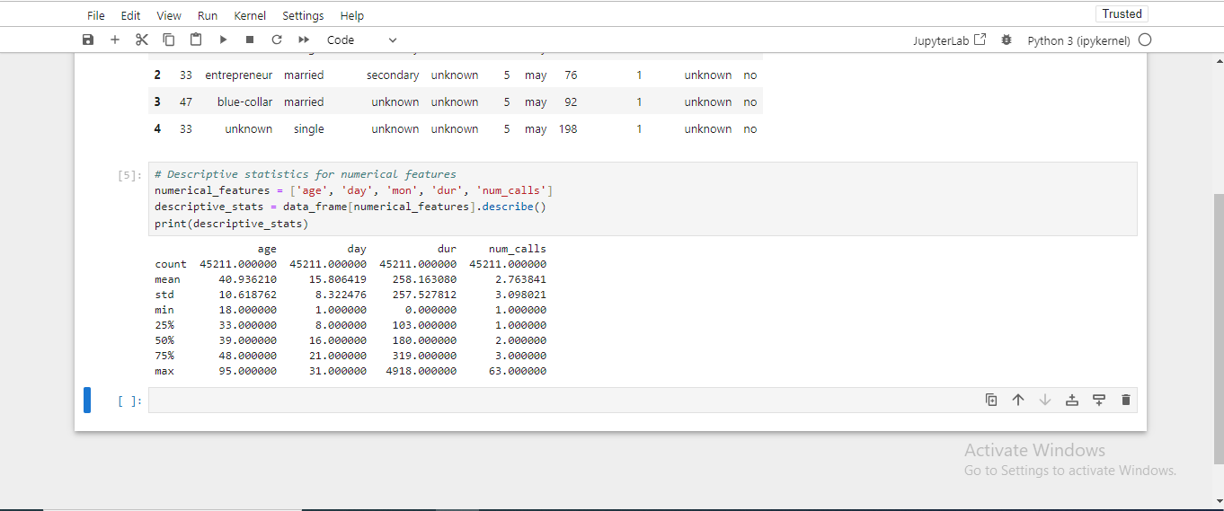
Figure 1: Jupyter Notebook Code and Output: Descriptive Statistics for Numerical Features

2. 1. 2 Frequency Analysis of Other Categorical Variables
The categorical features were checked to provide an idea of their distribution. Concerning the descriptive analysis of the categorical variables, identifying the most frequent values for specific variables(Hancock, J.T. and Khoshgoftaar, T.M., 2020) was of interest; thus, the following variables were considered: job, marital, education_qual, call_type, and prev_outcome. For example, the number of customer visits in different job types and the previous campaign results (prev_outcome) give the information about customers and previous campaigns.
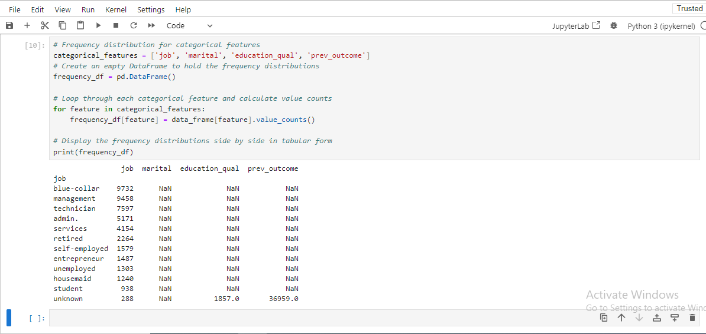
Figure 2: Jupyter Notebook Code and Output: Frequency Distribution of Categorical Features

2. 2 Handling Missing Values
Data missing affects the model’s efficiency, so managing it is relevant (Emmanuel, T., Maupong, T., Mpoeleng, D., Semong, T., Mphago, B. and Tabona, O., 2021). It was analyzed that the dataset contained no missing values in the numerical as well as in the categorical characteristics. For categorical data, where blank fields were evident the mode for the respective category was used where there were blank fields in the test data set since it was deemed fit for this kind of data, for numerical data where at some juncture the fields were blank the median was used instead of the mean because median is less volatile in presence of outliers. On such features as prev_outcome, if there were values marked “unknown”, they were included as a separate characteristic.
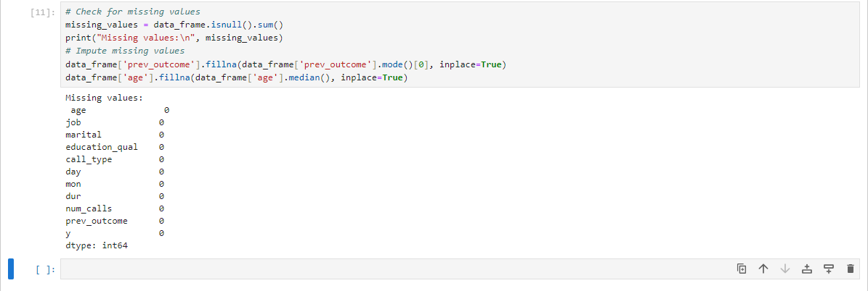
Figure 3: Jupyter Notebook Code and Output: Missing Value Analysis and Imputation

2. 3 Outlier Treatment
Similar to numbers, outliers were explored in age, dur, and num_calls. Outliers were presented with the help of boxplots, and especially, the call duration was considered because it could differ greatly. With regards to dur, cases of outliers were dealt with by using the IQR method of setting the limits on extreme values that might affect the models. Dealing with outliers was an important issue to enhance the stability of the machine learning models.
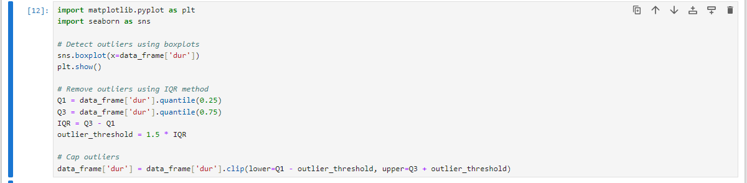
Figure 4: Jupyter Notebook Code: Outlier Detection and Removal
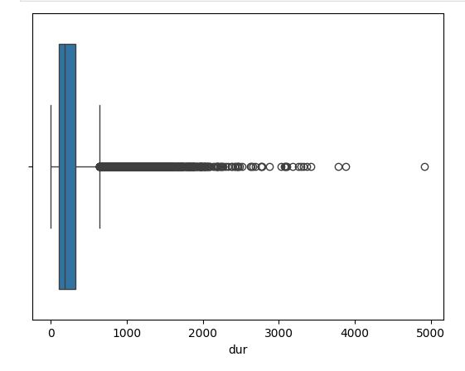
Figure 5: Box Plot of Duration (dur)

2. 4 Data Visualization

2. 4. 1 Representation of Other Qualitative Characteristics
Histograms and boxplots of numerical variables such as, age, dur, and num_calls were made. The bar chart of age gave information about the age group of customer reached by the campaign and the graph of num_calls gave idea about how many times customer was called.
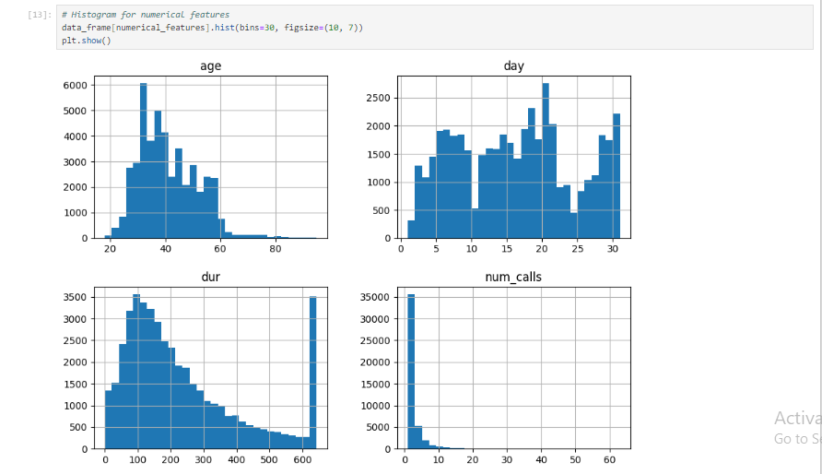
Figure 6: Histograms of Numerical Features: Age, Day, Dur, and Num_calls

2. 4. 2 Visualization of Categorical Features
Histograms were employed to plot the non-numeric nominal variables such as job, marital status, and prev_outcome. Thus it became clear trends like, which types of jobs dominated the customer’s subscriptions and which previous campaign outcomes (prev_outcome) were in highest correlation with current customers.
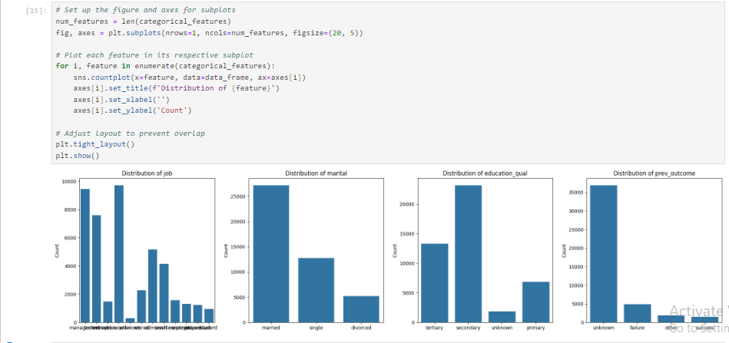
Figure 7: Jupyter Notebook Code and Output: Categorical Feature Distributions

2. 4. 3 Co relation between features and target variable
To test the correlation between some of the features to the target variable (y) which represents customer subscription to the insurance product, scatter plot and box plot were employed. For instance, the interaction of dur (call duration) and y was investigated and it was found that, calls that took longer time are likely to occasion a subscription. Similarly the cross-tab of categorical data such as prev_outcome and call_type and y has been used to find out the important customer conversion pattern.
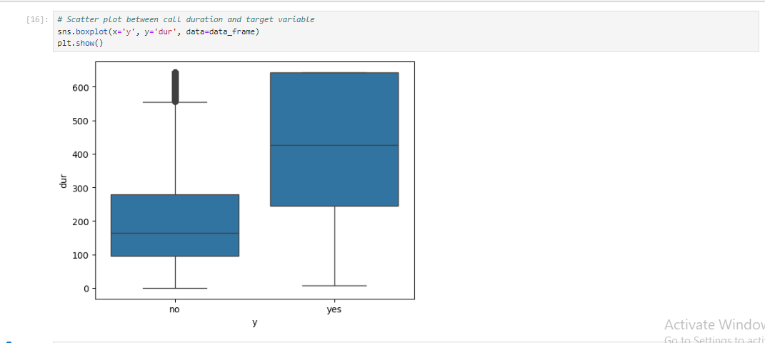
Figure 8: Box Plot of Call Duration (dur) by Target Variable (y)

CHAPTER TWO: MODEL SELECTION AND TRAINING

3. 1 Data Splitting

3. 2. 1 Train-Test Split Methodology
Splitting of data was done into training, and testing data so as to ensure that the performance of the model could be compared appropriately (Nguyen, Q.H., Ly, H.B., Ho, L.S., Al-Ansari, N., Le, H.V., Tran, V.Q., Prakash, I. and Pham, B.T., 2021). The training set is involved in making the model whereas the testing set is used to check the generality of the model. The above method is useful in realization of a capacity of carrying out the model with unseen data.
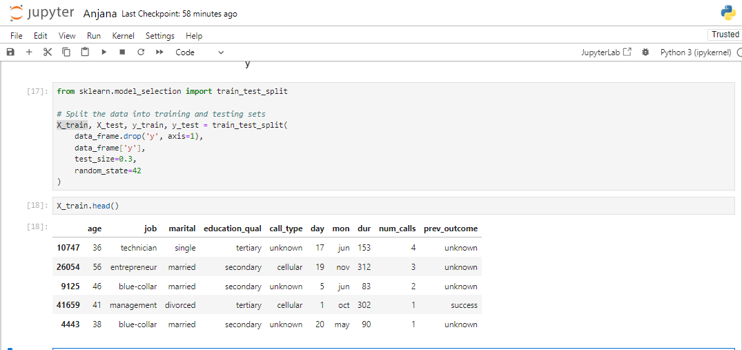
Figure 9: Jupyter Notebook Code and Output: Data Splitting and Sample Data

3. 2. 2 Stratified Splitting for Imbalanced data
Since the target variable can potentially be imbalanced it means that there are more non-subscribers than subscribers; by use of stratified splitting we are able to maintain the proportion of each class in both the training and test data sets. This approach avoids this kind of distortion and gives a much better picture of a model’s performance than using the hold-out method.
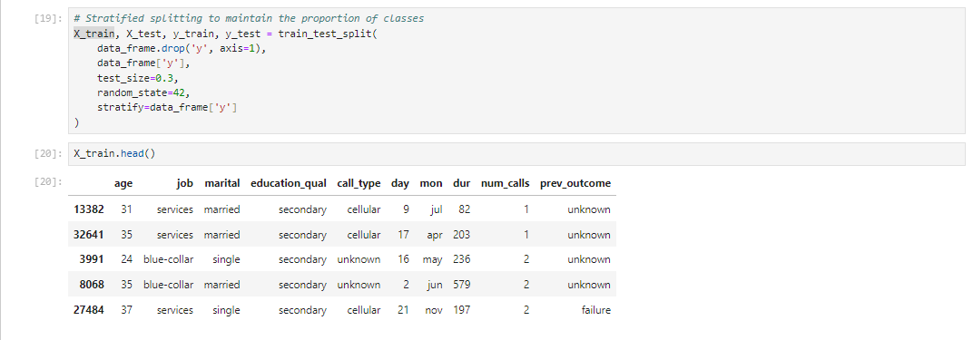
Figure 10: Jupyter Notebook Code and Output: Stratified Data Splitting and Sample

3.2 Model Selection

3.2.1 Logistic Regression
Logistic Regression is a fundamental classification algorithm used to predict the probability of a binary outcome (Fernandes, A.A.T., Figueiredo Filho, D.B., Rocha, E.C.D. and Nascimento, W.D.S., 2021). It is suitable for this task because it estimates the probability of a customer subscribing to the insurance product based on various features. The logistic function ensures outputs are between 0 and 1, making it ideal for binary classification.
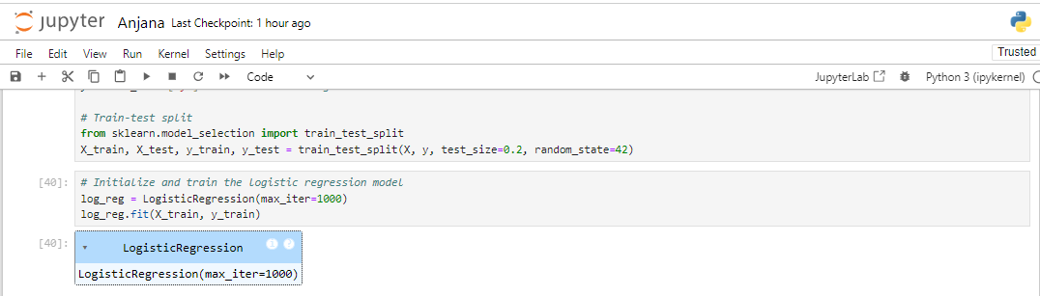
Figure 11: Jupyter Notebook Code: Logistic Regression Model Training

3.2.2 Random Forest
Random Forest is an ensemble learning method that combines multiple decision trees to improve predictive performance and control overfitting (Kavzoglu, T. and Teke, A., 2022). It is effective for handling complex interactions between features and is robust to noise and outliers. It provides feature importance scores, which can be useful for understanding which features most influence predictions.
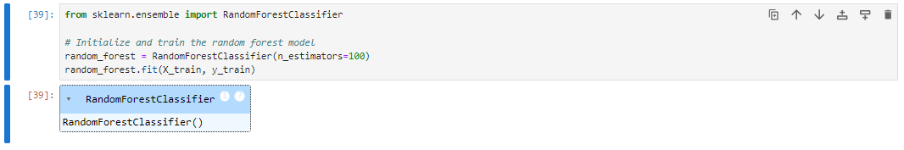
Figure 12: Jupyter Notebook Code: Random Forest Model Initialization and Training

3.2.3 Justification of Model Choices
Logistic Regression was chosen for its simplicity and interpretability, which helps in understanding the relationship between features and the target variable. Random Forest was selected for its robustness and ability to handle complex datasets with interactions between features. Both models offer complementary strengths: Logistic Regression provides a straightforward probabilistic interpretation, while Random Forest offers enhanced performance through ensemble learning.

CHAPTER THREE: MODEL INTERPRETATION AND EVALUATION

4.1 Model Interpretation

4.1.1 Feature Importance in Logistic Regression
In Logistic Regression, the feature importance is defined by the coefficients that are given to each feature (Saarela, M. and Jauhiainen, S., 2021). As for the value of coefficients, the greater the absolute value of the coefficient, the more important the feature is.
Here’s how to extract and interpret feature importance from a logistic regression model:
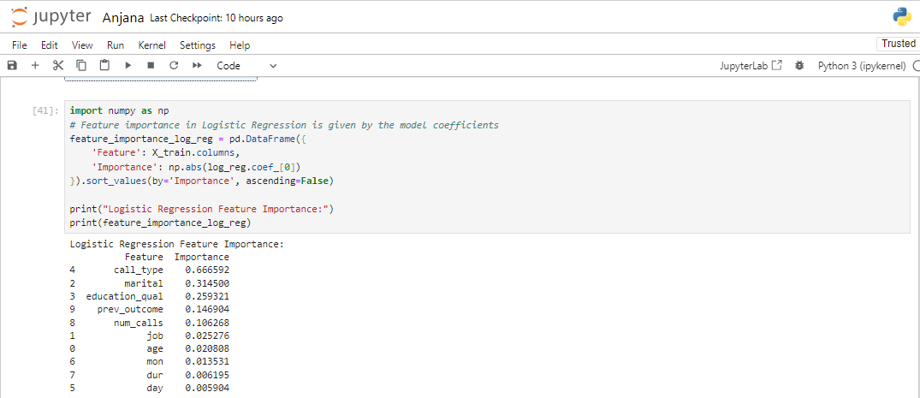
Figure 13: Jupyter Notebook Code and Output: Logistic Regression Feature Importance
In Logistic Regression, the higher absolute coefficient value is reveled for call_type, meaning that the way of the call plays the crucial role in the decision of the customer subscribes to the insurance product. This is succeeded by marital status and education level, and powerfully indicates that other demographic characteristics are still at work concerning customer decisions. Surprisingly, there is a similar moderate importance of prev_outcome from the prior campaign and the number of calls done to the customer. As for the variables such as job, age and month, they seem to have lower value, this implies that they are inconsequential and exert less impact in the model.

4.1.2 Feature Importance in Random Forest
In Random Forest, when feature importance is calculated this tells us how much, on the average, a particular feature has reduced the impurity across the entire set of the trees in the forest.
Here’s how to train a Random Forest model and extract feature importance:
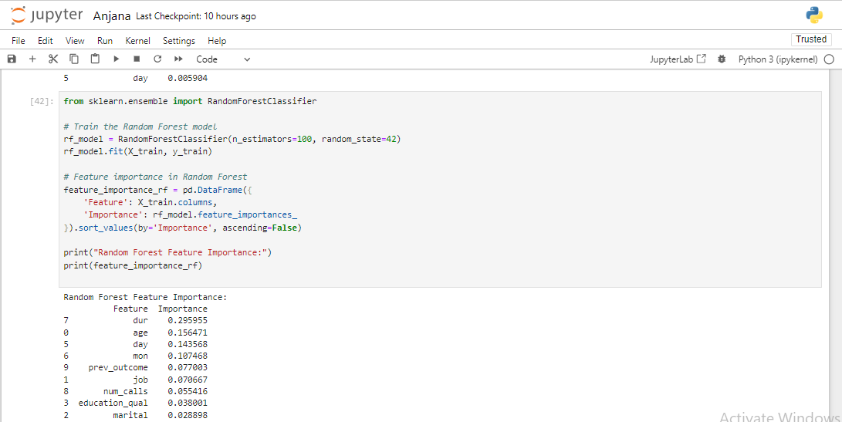
Figure 14: Jupyter Notebook Code and Output: Random Forest Feature Importance
On the other hand, Random Forest gives the highest importance to duration of contact (dur) thereby suggesting that the time spent on the call determines whether a subscriber is likely to subscribe or not. Age, day, and month are also valuable features, proving the importance of target customers and when these customer-equipment-interaction cases occur for this model. Nevertheless, the feature prev_outcome stays significant which enforces the fact that previous outcomes impact today’s results of the campaign. Unlike Logistic Regression, Random Forest shows that the predictors call_type, marital status, and educational qualifications are least important to RF, then the other features.
In general, they both shed light on the significance of the feature; while, Logistic Regression mainly targets demographics and contact types, Random Forest more concerns with time period of interaction and so on. These variations brought out features that set these models apart as far as their understanding and utilization of data is concerned for purposes of making predictions.

4.2 Model Evaluation

4.2.1 Evaluation Metrics: Accuracy, Precision, Recall, F1-Score

Tuned Logistic Regression Evaluation:
- Best Parameters: {'C': 0.01}
- Accuracy: 0.8832
- Precision: 0.5355
- Recall: 0.2420
- F1-Score: 0.3333
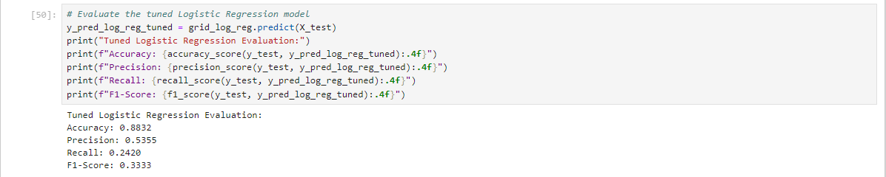
Figure 15: Jupyter Notebook Code and Output: Tuned Logistic Regression Model Evaluation
This tuned Logistic Regression model has a high accuracy of 88%. The similarity coefficient was evaluated at 32%, which is regarded as quite a good overall classification result. However, its precision could be higher, and it is at 53.55%, this point to the fact that although the model can correctly classify some positive cases, it also classifies many more cases as positive when they are not. The recall at 24% can be translated as meaning that the model locates a lower number of actual positive cases. The F1-Score of 33.33% indicates a reasonable amount of accuracy and recall, but there is still potential for improvement, especially when it comes to the identification of positive samples.

Tuned Random Forest Evaluation:
- Best Parameters: {'n_estimators': 150, 'max_depth': 10}
- Accuracy: 0.8978
- Precision: 0.6462
- Recall: 0.3382
- F1-Score: 0.4440
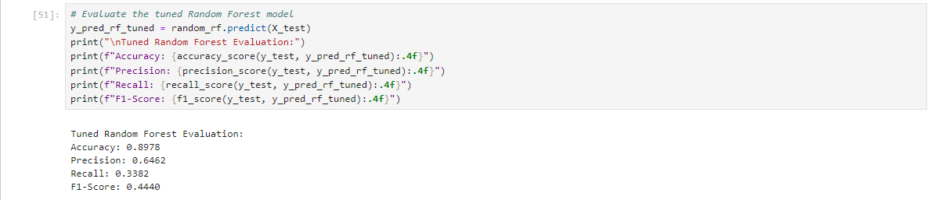
Figure 16: Jupyter Notebook Code and Output: Tuned Random Forest Model Evaluation
Even the tuned Random Forest model gives a relatively higher accuracy of 89% or about 0. 89. Thus, it performs 78%, indicating that it is better luck than the Logistic Regression model. The precision is also better here at 64.62%, this should mean that many of the identified positive outcomes in the prediction analysis really constitute positive cases. The recall of 33, that is why 82% shows that the Random Forest model performs better than the Logistic Regression model in terms of sensitivity and ability to detect positive outcomes. The F1-Score of 44.40% is slightly more favorable when it comes to precision and recall in evaluating diverse instances, thus establishing the importance of Random Forest in handling the problem of imbalance of the target variable.

4.2.2 Hyperparameter Tuning
Hyperparameter tuning means the adjustment of the parameters it has not learnt from the training data set in order to achieve probable improvement in the performance of the machine learning model (Weerts, H.J., Mueller, A.C. and Vanschoren, J., 2020). Hyperparameters are set prior to training and differ from model parameters that are estimated during training and which can dramatically affect the model’s performance.

Importance
Hyperparameters optimization is important since it enables one to identify the right settings that boosts the models ways of making correct predictions, minimizes over-fitting and increases the chances of generalizing to new data. It is recommended that tuning should be done properly in order to get the model give accurate predictions and get better performance indicators.
- Logistic Regression: For case of Logistic Regression the best value as hyperparameter was `C = 0. 01`. It should be noted that in case of Logistic Regression the `C` parameter regulates the response of the model to the regularization, and smaller values of this parameter constitute stronger regularization. This is useful in overcoming overfitting especially when the model seeks to impose penalties on large coefficients in the model.
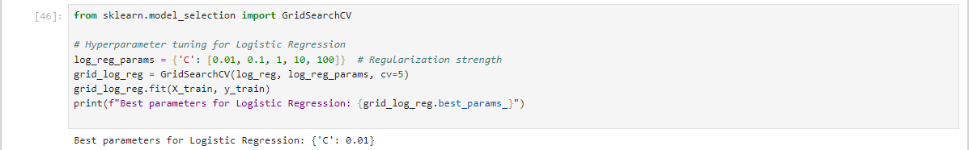
Figure 17: Jupyter Notebook Code and Output: Hyperparameter Tuning for Logistic Regression
- Random Forest: The best hyperparameters for Random Forest were found to be ‘number of trees = 150’ and ‘maximum tree depth = 10’. The `n_estimators` parameter shows the number of decision trees in the forest and more trees add favorable impact on the model. The `max_depth’ parameter limits the depth of each individual tree to avoid overfitting, that is to say it prevents the model from being excessively complex.
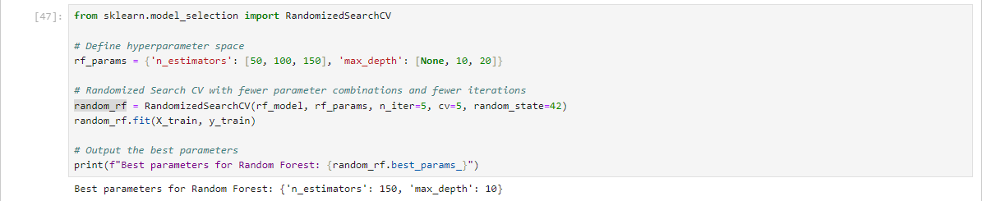
Figure 18: Jupyter Notebook Code: Hyperparameter Tuning for Random Forest Model

4. 2. 3 Model Performance Comparison
The comparison of model performance based on accuracy, precision, recall, and F1-Score reveals that the Random Forest model outperforms the Logistic Regression model across all metrics:
- Accuracy: In Random Forest methodology, the percentage of accuracy was found as 0.8978 compared to the Logistic Regression which has attributed a value of 0.8832. This means that the Random Forest model has a better ability of correctly predicting the right outcome most of the times.
- Precision: Random Forest achieved the accuracy of 0.6462 is higher than that of Logistic Regression, which stands at 0.5355. This implies that probability distribution of true positives among all the positive predictions is higher in the Random Forest model.
- Recall: Recall in case of Random Forest was 0.3382 which is much higher than that Logistic Regression got only 0.2420. From all these, it can be seen that Random Forest performs better in coming up with the actual positives among the dataset.
- F1-Score: And an F1 Score of 0.4440, Random Forest has done better than Logistic Regression with accuracy of 0.3333. In the same manner, the F1-Score that represents a trade-off between precision and recall also demonstrate that Random Forest offer more balanced performance.

Thus, based on the Random Forest model, it can be concluded that it performs better than the Logistic Regression model, which proves its ability to work with all the features and peculiarities of the data. The presented evaluation confirms how essential hyperparameter optimization process and, specifically, the choice of the model, are in attaining the best overall performance.

CHAPTER FOUR: DISCUSSION AND INSIGHTS

5.1 Key Insights from Data Exploration
From the data exploration phase, several key insights emerged:
- Customer Demographics: Employment type was revealed to be one of the most problematic predictors while age also revealed to have a problem with predicting the likelihood of subscription. The change in subscription by age and occupation gave an indication of marketing techniques required to make adjustments to appeal different age group and appropriate employee subscribers.
- Campaign Details: The length of the final contact and the total number of contacts within the given campaign dictated whether the campaign would be successful in terms of subscriptions. More contact time and more contacts in general meant relatively higher subscription rates.
- Previous Outcomes: Self-generated data indicated that the effectiveness of previous marketing campaigns influenced the rate of customers subscribing. Customers who tasted success were always likely to enrich themselves with more knowledge by subscribing.
- Seasonality: The number of days and month of last contact were useful in indicating whether there are certain months or days in a month customers visits more frequently hence implying that certain times of the year may influence subscription rates.

5.2 Model Performance Summary
The evaluation of the models revealed the following performance metrics:
Table 1: Model performance classification metrics
Model | Accuracy | Precision | Recall | F1-Score
Logistic Regression | 0.8832 | 0.5355 | 0.2420 | 0.3333
Random Forest | 0.8978 | 0.6462 | 0.3382 | 0.4440

It was observed throughout the experiment that Random Forest model performed better than Logistic Regression for all the experiments indicating that the former captures the dependencies in the data better. Computing greater precision, recall, and F1-Score point to a better model of identifying the real positives while weighing the strengths of precision against the weaknesses of recall.

5. 3 Feature Inputs to Target Output
Feature importance analysis highlighted the following contributions:
- Logistic Regression:
- Call Type: The most influential feature with the suggestion of the importance for the method of communication.
- Marital Status and Education Qualification: Also important showing how these demographic factors affect subscription probability.
- Random Forest:
- Duration of Last Contact: Meaning the most influential feature may be safely stated that the length of the conversation is a rather significant factor in the subscriptions.
- Age and Day of Contact: Criterion that affect the probability of subscription, as well as the customer age and time of contact.
These examples show that even though there are features that are essential to all models (for example, duration of contact), there are also features that are relevant only to a given model.

5. 4 Business Implication to Business Decisions
The findings offer actionable insights for refining marketing strategies:
- Targeted Marketing: Concentrate on those customers who have response well to past marketing communication. To increase the effectiveness of campaigns, detailed demographic and contact information are needed.
- Optimal Contact Duration: Dwell more closely with the possible customers as messages that have longer interaction bring in higher subscription.
- Seasonal Strategies: As stated, make changes to marketing depending on the seasonality that has been noted. This way you will be able to direct more of the resources that you have to the periods that have higher subscription rates to allow for improvement of the campaign.
In other words, the analysis and model performance provided directions for maximizing marketing strategies and enhancing business decisions; thus, stressing the significance of Data-Driven Marketing.

CONCLUDING REMARKS

Customer subscription to an insurance product this work also sought to analyze and assess models for the prediction of customers’ subscriptions. The key findings include:
- Data Insights: These here are key parameters that determine the choices on subscription: the time elapsed before the last contact, age and the degree of interactions. Of even greater significance were demographic factors including job type, marital status as well as the level of education.
- Model Performance: When compared with Logistic Regression Random Forest achieved marginally better accuracy, precision, recall and F1-Score. They have uncovered how Random Forest is a more suitable algorithm to work with all the intricacies embedded in a set of data.
- Feature Importance: In Random Forest, the duration of the last contact featured highest importance and in Logistic Regression, the communication method was considered significant.

6.2 Recommendations for HashSysTech Insurance
Based on the findings, the following recommendations are proposed for HashSysTech Insurance:
- Leverage Random Forest Model: Use Random Forest model for the prediction of customer subscriptions because of best output it provides. Apply this entailed model for enhancing the accuracy of advertising campaign and its customization or targeting.

- Optimize Contact Strategies: More emphasis should be made towards the extension and effectiveness of customer personalities, satisfied customers have long and deep personalities will subscribes and be loyal.
- Segment Marketing Efforts: Conduct market segmentation based on demographics to be able to create a right marketing message for the customers. In my case, those who incurred positive results in previous experiences should be prioritized for benefits and the young in age and those with appropriate job types.

6. 3 Future Work
To further enhance the effectiveness of marketing strategies and predictive models, the following future work is recommended:
- Incorporate Additional Data: Consider adding more data into the models like customer feedback, social media feedbacks, and other outside economic factors to get even a richer degree of accuracy.
- Model Refinement: Explore more methods for the improvement of modeling methods and ensemble methods for raising effectiveness of predictions. Consequently, the performances of models, including Gradient Boosting or Neural Networks, should be taken into comparison with the existing ones.
- Feature Engineering: Use the results of interaction patterns and customers’ behavior to develop the new features for enhancing the model.
- Real-Time Implementation: Create and build the, proceed to use real-time model execution to optimize marketing shifts and match interactions and campaigns.
In conclusion, the findings of the analysis have offered the necessary suggestions and the implementation guidelines for HashSysTech Insurance. In particular, the use of the state-of-the-art techniques in predictive modeling and marketing, the company could increase efficiency of acquisitioned processes and further improve campaign’s performance (Gangwani, D. and Zhu, X., 2024).

BIBLIOGRAPHY

Kousky, C., 2022. Understanding disaster insurance: New tools for a more resilient future. Island Press.
Larsen, K.R. and Becker, D.S., 2021. Automated machine learning for business. Oxford University Press.
Sundaram, R., Sharma, D.R. and Shakya, D.A., 2020. Digital transformation of business models:
A systematic review of impact on revenue and supply chain. International Journal of Management, 11(5).
Watkins, M.W., 2021. A step-by-step guide to exploratory factor analysis with SPSS. Routledge.
Hancock, J.T. and Khoshgoftaar, T.M., 2020. Survey on categorical data for neural networks.
Journal of big data, 7(1), p.28.
Emmanuel, T., Maupong, T., Mpoeleng, D., Semong, T., Mphago, B. and Tabona, O., 2021. A survey
on missing data in machine learning. Journal of Big data, 8, pp.1-37.
Nguyen, Q.H., Ly, H.B., Ho, L.S., Al-Ansari, N., Le, H.V., Tran, V.Q., Prakash, I. and Pham,
B.T., 2021. Influence of data splitting on performance of machine learning models in prediction of shear strength of soil. Mathematical Problems in Engineering, 2021(1), p.4832864.
Fernandes, A.A.T., Figueiredo Filho, D.B., Rocha, E.C.D. and Nascimento, W.D.S., 2021. Read
this paper if you want to learn logistic regression. Revista de Sociologia e Política, 28, p.006.
Kavzoglu, T. and Teke, A., 2022. Predictive Performances of ensemble machine learning algorithms
in landslide susceptibility mapping using random forest, extreme gradient boosting (XGBoost) and natural gradient boosting (NGBoost). Arabian Journal for Science and Engineering, 47(6), pp.7367-7385.
Saarela, M. and Jauhiainen, S., 2021. Comparison of feature importance measures as explanations
for classification models. SN Applied Sciences, 3(2), p.272.
Weerts, H.J., Mueller, A.C. and Vanschoren, J., 2020. Importance of tuning hyperparameters of
machine learning algorithms. arXiv preprint arXiv:2007.07588.
Gangwani, D. and Zhu, X., 2024. Modeling and prediction of business success: a survey. Artificial Intelligence Review, 57(2), p.44.
Borges, A.F., Laurindo, F.J., Spínola, M.M., Gonçalves, R.F. and Mattos, C.A., 2021. The strategic use
of artificial intelligence in the digital era: Systematic literature review and future research directions. International journal of information management, 57, p.102225.

